

SEMESTER PROJECT REPORT

Project Title
Mediore+
Smart Clinic& Patient Management System

Submitted By: Muhammad Kaleem Aqib Ramzan Tooba Afzal

Section:
6TH/2E

Subject:
Advance Programming

Supervisor:
Dr. Omer Ajmal

Department:
Computer Science

University:
The Islamia University Of Bahawalpur

1. Introduction
2. Project Structure
3. Modules of the System
4. Database Design
4.1 Simple ER Diagram
5. C# Concepts Used in the Project
6. Asynchronous Programming (Async / Await)
7. How the Service Classes Work
8. Application Output
9. Work Distribution
10. Challenges Faced
11. Future Enhancements
12. Conclusion

- Introduction:
Medicore is a desktop application built in C# windows forms to manage the clinic work patients, doctors, appoinments and billing by using a Sql Server database. The project is split into two parts: Medi Core.Core which holds all the logic and MediCore.WindowsApp which holds all the screens the user interface.
When the app opens it shows a Dashboard with quick stats and a sidebar to move between the Patients Doctors, Appointments, Billing, Reports and Logout.

- Project Structure:

Project | Contains
Medicore.core | Contracts, Models And Services
Medicore.WindowsApp | Forms and views

2.1 Inside MediCore.Core
- Contracts: IPatientService , IDoctorService, IAppointmentService and IBillingService
- Models: Patient, Doctor, Appointment and Bill these classes hold the data
- Services: DBPatientService, DBDoctorService, DBAppointmentService and DBBillingService these connect to SQL Server.
- Utilities: AppointmentStatusEnum, GenderEnum, PaymentStatusEnum and Role Enum

2.2 Inside MediCore.WindowsApp
- Forms: MainForm, PatientForm, DoctorForm, AppointmentForm, BillForm
- Views: DashboardView, PatientsView, DoctorView, Appoinment view shown inside MainForm one at a time
- MainForm: uses one method, ShowView(), to switch between views when a sidebar button is clicked

- Modules of the System:
Module | Role
Dashboard | Landing screen showing table of patient,doctors appoinments,revenue and todays appoinments
Patients | Add, edit, delete and view patient records including name, age, gender, contact and blood group.
Doctors | Add, edit, delete, and view doctor profiles including name, specialty, and contact information.
Appoinments | Schedule and manage appointments by linking a patient with a doctor along with appointment date and status.
Billing | Generate and track patient bills, including bill amount and payment status.
Logout | Logout ends the current session.

- Database Design:
Tables | Columns
Patient | Id (Primary Key) Name, Age, Gender, Contact and BloodGroup.
Doctor | Id (Primary Key) Name, Specialty and Contact.
Appoinment | Id (Primary Key) PatientId (Foreign Key) DoctorId (Foreign Key) Date and Status.
Bill | Id (Primary Key) PatientId (Foreign Key) Amount, Date, and Status. Each bill is associated with a specific patient through the PatientId foreign key.

4.1 Simple ER Diagram
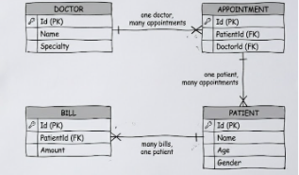
- C# Concepts Used in the Project:

• Class & Object: Used in the Patient, Doctor, Appointment and Bill model classes.
• Interface: Implemented through IPatientService, IDoctorService, IAppointmentService and IBillingService service contracts.
• Encapsulation: Applied by using public get/set properties in all model classes.
• Inheritance: Forms inherit from the Form class, while Views inherit from the UserControl class.
• Enum: Used through AppointmentStatusEnum, GenderEnum, PaymentStatusEnum and RoleEnum.
• Event-Driven Programming: Implemented using button click events such as btnAdd_Click and btnDelete_Click.
• ADO.NET: Used for database connectivity through SqlConnection, SqlCommand and SqlDataReader.
• Asynchronous Programming: Implemented using async and await to keep the user interface responsive during database operations.
• DataGridView: Used to display records in PatientsView, DoctorView, AppointmentsView and BillingView.

- Asynchronous Programming (Async / Await):
Using async and await keeps the app from freezing up when it talks to the database. So people can keep clicking around and using features even when data is still loading or updating behind the scenes.
public async Task<List<Patient>> GetAllPatientsAsync()
{
List<Patient> patients = new List<Patient>();

using (SqlConnection conn = new SqlConnection(_connectionString))
{
await conn.OpenAsync();
string query = "SELECT * FROM Patient";
SqlCommand cmd = new SqlCommand(query, conn);
SqlDataReader reader = await cmd.ExecuteReaderAsync();

while (await reader.ReadAsync
{
Patient patient = new Patient();
patient.Id = Convert.ToInt32(reader["Id"]);
patient.Name = reader["Name"].ToString();
patient.Age = Convert.ToInt32(reader["Age"]);
patient.Gender = reader["Gender"].ToString();
patient.Contact = reader["Contact"].ToString();
patient.BloodGroup = reader["BloodGroup"].ToString();
patients.Add(patient);
}
}

return patients;
}
- How the Service Classes Work:
Every service class sticks to the same pattern for handling database tasks. It keeps things simple and makes the code easy to follow. They all use parameterized queries too which means Add, Update, Delete and Read operations are safer and there is less risk of security problems.

- Application Output:
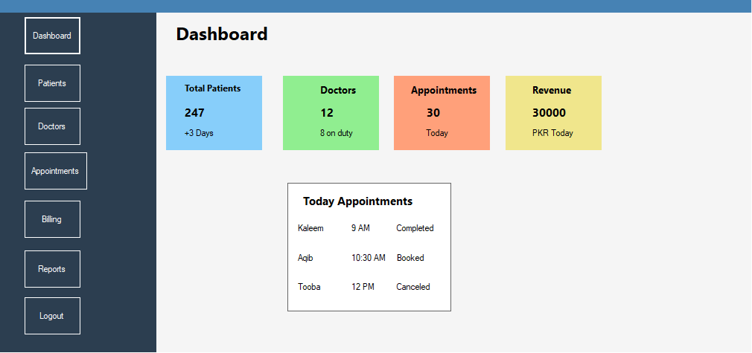
When Main form opens the Dashboard view loads first. It shows four summary cards and a list of today appointments confirming that the application is correctly reading live data from the database. This screen shot shows the actual running application.

- Work Distribution:
Member | Contribution
Kaleem | Responsible for database design, service classes, asynchronous database connectivity, debugging and documentation.
Aqib | Responsible for developing Patient and Doctor modules, including forms, views, and service integration.
Tooba | Responsible for the Billing module, appointment view and service classes contribution.
10. Challenges Faced:
Getting the SQL Server connection set up was tricky. The connection string needed just the right server and database details and getting that wrong caused some real headaches. Keeping the app smooth during those database operations was another hurdle but async programming took care of that.
11. Future Enhancements:
Down the line the system can get a role-based login so that different users get different permissions based on their roles. Also, the Reports module could get an upgrade think generating PDF reports for patients, appointments and billing records.
12. Conclusion:
MediCore+ is a user-friendly and efficient desktop application developed to manage clinic operations in a simple and organized way. The system uses a clear structure by separating logic from the user interface ensuring better maintenance and easy future improvements.
The application securely connects with SQL Server using safe database practices and uses asynchronous programming to keep the system fast and responsive. Overall MediCore+ successfully demonstrates the practical use of Advanced Programming concepts by creating a real-world healthcare management solution.

